**Random walk**

Name \ Abdulrahman salah anwer

The main

package com.company;  
  
import java.util.Scanner;  
  
public class Main {  
 public static void main(String[] args) {  
 char move;  
 int StepsNumber;  
 Step newStep = new Step();  
 Scanner scn = new Scanner(System.*in*);  
 System.*out*.println("Please Enter The Number Of Steps");  
 StepsNumber = scn.nextInt();  
  
 for (int step = 1; step <= StepsNumber; step++) {  
 move = newStep.XYCoordinatesDist();  
 if (move == 'F') {  
 newStep.Y++;  
 } else if (move == 'L') {  
 newStep.X--;  
 } else if (move == 'R') {  
 newStep.X++;  
 }  
 System.*out*.println(newStep.toString());  
 newStep.stepNum++;  
 }  
 System.*out*.println("\nThe Simulation End With "+StepsNumber+" Steps" +  
 "\nThe final Position is {X=" +newStep.X +",Y="+newStep.Y+"}");  
 }  
}

The Step Class

package com.company;  
  
import java.util.Random;  
  
public class Step {  
 int X = 0;  
 int Y = 0;  
 int stepNum = 1;  
  
 public char XYCoordinatesDist() {  
 Random rand = new Random();  
 int random_number = rand.nextInt(100) + 1;  
 char XYvalue = ' ';  
 if (random_number <= 50) {  
 XYvalue = 'F';  
 }  
 if (random_number >= 51 && random_number <= 80) {  
 XYvalue = 'L';  
 }  
 if (random_number >= 81) {  
 XYvalue = 'R';  
 }  
 return XYvalue;  
 }  
  
 @Override  
 public String toString() {  
 return "Step number " + stepNum + " {" +  
 "x=" + X +  
 ", y=" + Y +  
 '}';  
 }  
}

The output

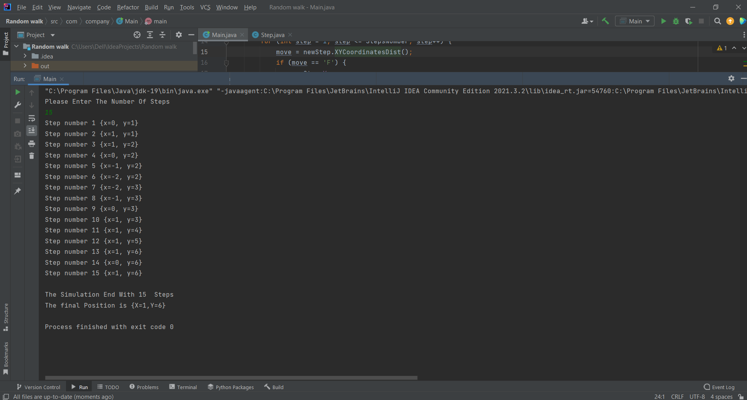

Done..